Below is the use case of the ansible with which we are going to apply infra as a code(iaac). Below we have 3 tiers load balancer , application , db

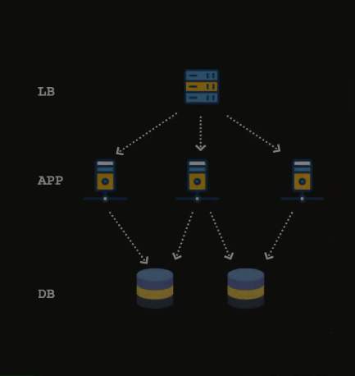

We are going to break down each layer and discuss each as a atomic unit

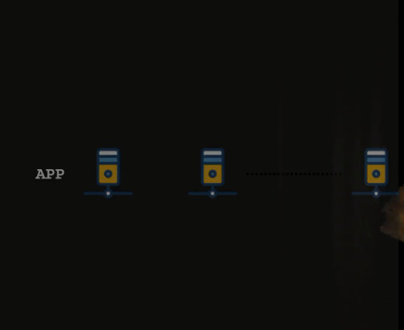

Our application tier consists of the same application which is deployed in multiple instances as above pic

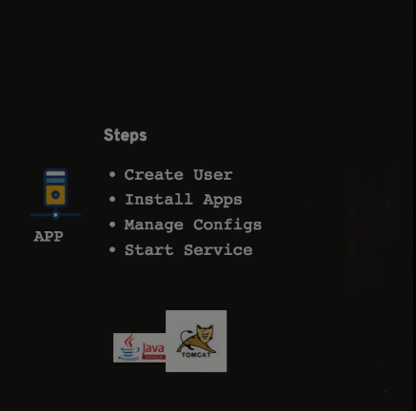

For each application may require the above tasks to get accomplished

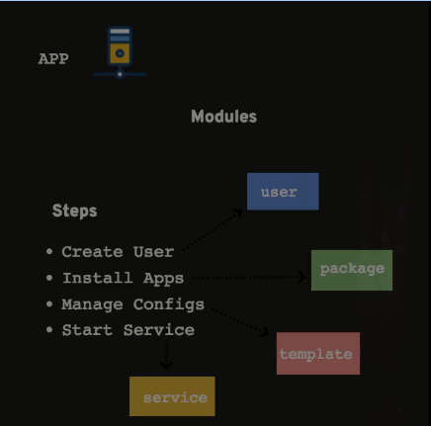

We mind mapped the modules that are needed to accomplish the given tasks

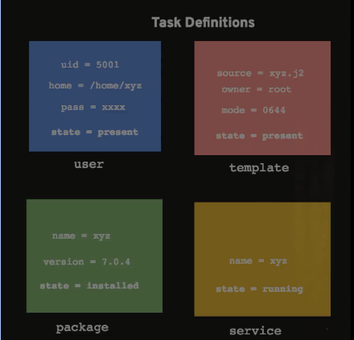

Breaking down the tasks with appropriate modules as above with specific props for each module

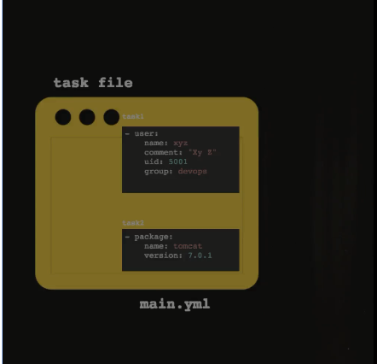

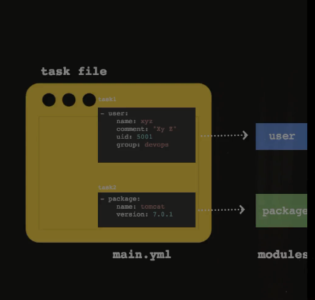

Will write the tasks pertaining to the requirement and place them in a role where the roles has many different files which involves templates,files,defaults,vars

Once the role is defined then we need apply them to the servers which are part of inventory

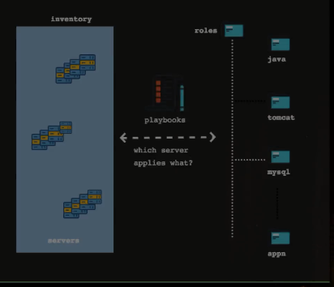

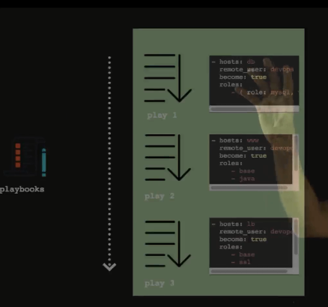

Then we define the playbooks as above to deploy the roles to the inventory in sequence as decided

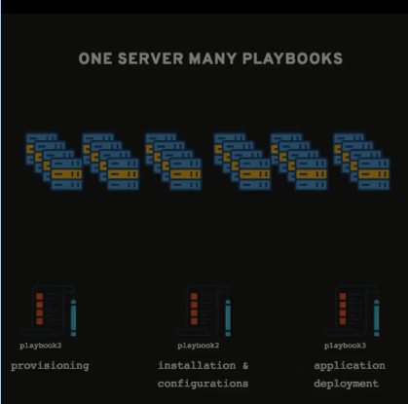

Ansible allows us to define different playbooks for the same set of servers as above

Code Organization Strategies

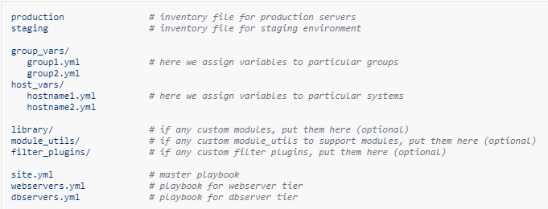

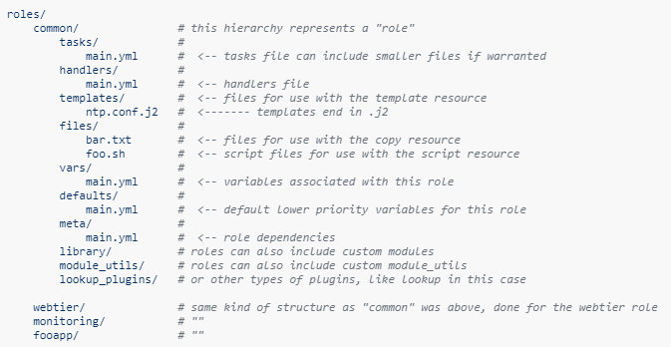

In addition to the above structure we will environments (directory on the root folder and place the production & staging inventory files in that) also it is good practice to add the ansible.cfg particular to the project where we will ansible related properties specific to that project.

Devops use case

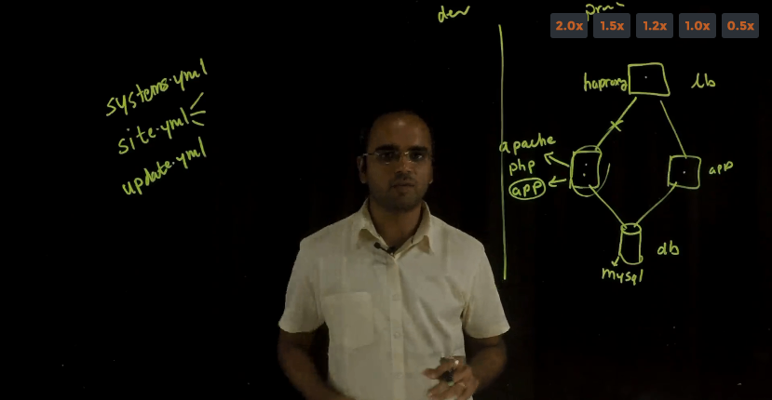

In this use case we have 3 tier app which involves Load balancer (haproxy) , application servers (apache,php,app(code itself)) and db servers which involves(mysql). So, We will write playbooks pertaining to the each tier which has to connect each tier to the other tier such LB be able to load balance the app servers and app servers be able to connect to the db. To connect these will write config files for the LB and app to connect to the mysql (usrname & pwd) .

So finally we will have the 3 different playbooks which are in above pic will call the particular roles when deployed the playbook. Also we need to write the update.yml which deploys the code in certain fashion such as update the db and removes the app from LB update the code and re add to LB and move on to other servers.

Below is the Code organization we are going to follow for this use case

